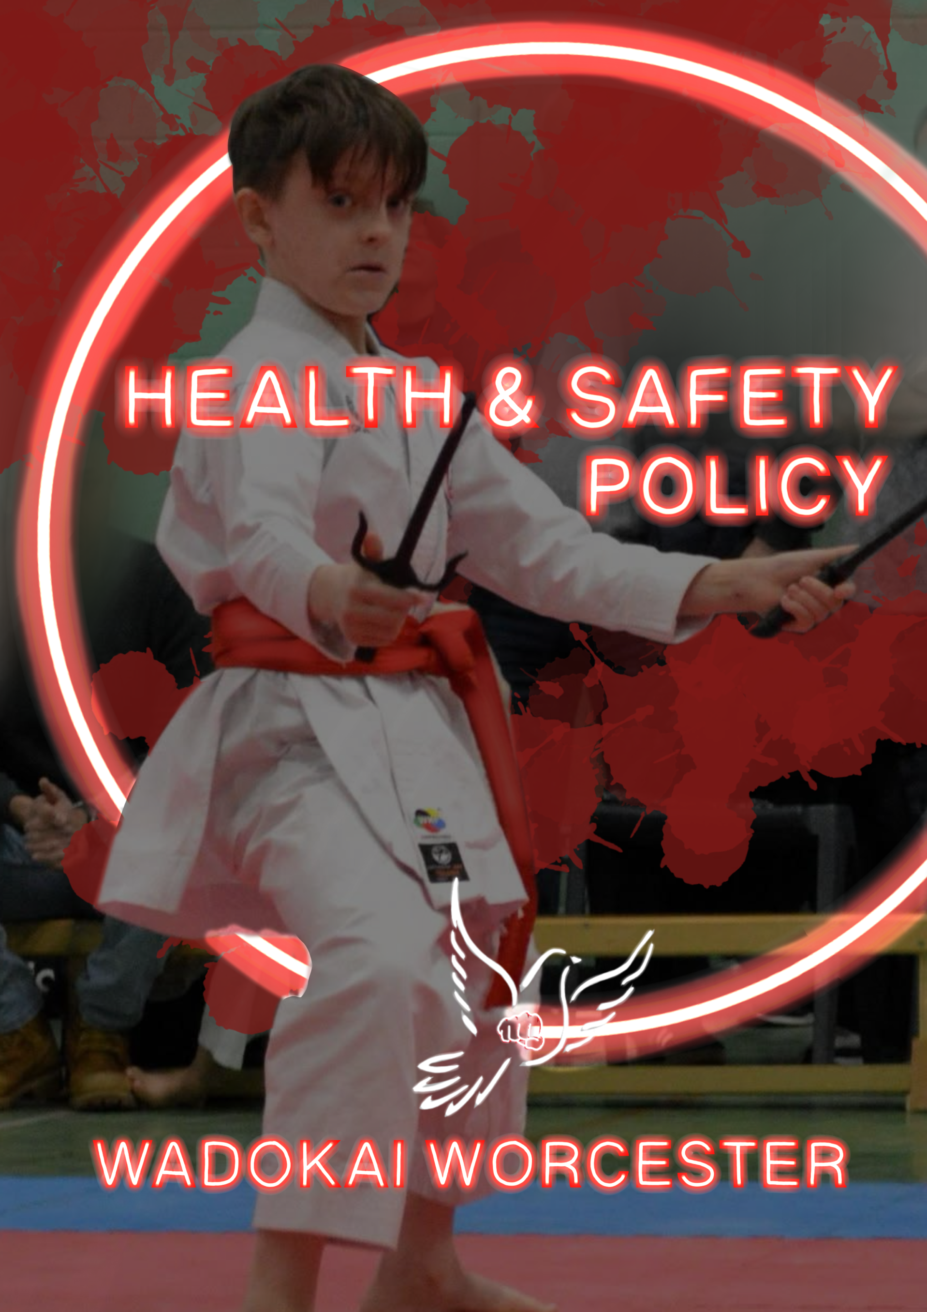

WadoKai Worcester Karate Health & Safety Policy
Introduction:
At WadoKai Worcester Karate, the health, safety, and wellbeing of our members, instructors, and visitors is our top priority. We are committed to maintaining a safe training environment that minimises risks and ensures compliance with all relevant UK health and safety laws, including the Health and Safety at Work Act 1974 and the Management of Health and Safety at Work Regulations 1999.
This policy applies to all club activities, instructors, students, parents/guardians, and visitors. It is reviewed annually to ensure ongoing compliance and improvements in health and safety standards.

1. Health & Safety Responsibilities
All individuals at WadoKai Worcester Karate share responsibility for health and safety. Specific responsibilities are outlined below:

1.1 Club Management Responsibilities
- Ensure compliance with health and safety legislation.
- Provide a safe training environment, free from hazards.
- Conduct risk assessments for all club activities.
- Ensure all instructors and staff are trained in health and safety procedures.
- Maintain appropriate first aid provisions, including first aid kits and trained first aiders.
- Ensure clear emergency procedures are in place and communicated.

1.2 Instructor Responsibilities
- Ensure all training sessions are conducted safely and in accordance with best practice.
- Identify and mitigate any potential hazards before and during training.
- Ensure students warm up and cool down properly to reduce the risk of injury.
- Report and document any incidents, injuries, or near misses.
- Ensure all equipment is safe and fit for use.

1.3 Student Responsibilities
- Follow all safety instructions provided by instructors.
- Wear appropriate protective gear as required for training.
- Report any injuries, hazards, or safety concerns to an instructor immediately.
- Respect training partners and maintain self-control during sparring and drills.

1.4 Parent/Guardian Responsibilities (for Junior Members)
- Ensure their child arrives and leaves safely from training sessions.
- Inform the club of any medical conditions or injuries affecting their child.
- Support club policies on discipline, behaviour, and safety.

2. Risk Assessment
To minimise risks, WadoKai Worcester Karate conducts regular risk assessments. These assessments identify hazards, assess potential risks, and determine appropriate control measures.
Common Risks and Control Measures:
Risk | Potential Hazards | Control Measures
Slips, Trips, and Falls | Wet floors, loose mats, poor footwear | Regular floor inspections, use of proper mats, and mandatory footwear policies
Physical Injury | Strains, sprains, fractures | Proper warm-up/cool-down, correct technique, instructor supervision
Overexertion | Heat exhaustion, dehydration | Mandatory water breaks, controlled training intensity
Infectious Diseases | Spread of illnesses, poor hygiene | Regular cleaning, personal hygiene enforcement, hand sanitiser stations

3. First Aid & Medical Provisions

3.1 First Aid
- WadoKai Worcester Karate maintains a fully stocked first aid kit at all training sessions.
- At least one instructor per session is first aid trained and holds an up-to-date certification.
- Any injuries must be reported immediately and documented in the Accident Report Log.
- Emergency procedures will be followed in serious cases, including contacting emergency services where necessary.

3.2 Medical Conditions
- All students must disclose any medical conditions that may affect their training.
- Emergency medication (e.g. inhalers, EpiPens) must be accessible during training.

4. Fire & Emergency Procedures
All members must familiarise themselves with the emergency procedures of the training venue.

4.1 Fire Safety
- Fire exits and escape routes must remain clear at all times.
- In case of fire, evacuate immediately and follow venue-specific fire safety procedures.
- Fire drills will be conducted periodically.

4.2 Emergency Evacuation
- In the event of an emergency, instructors will direct students to the assembly point.
- Parents/guardians will be contacted if a junior member is involved in an evacuation.

5. Safe Use of Equipment
- All equipment must be checked regularly for wear and damage.
- Faulty or damaged equipment must not be used and should be reported immediately.
- Protective gear (e.g. gloves, shin guards) must be worn during relevant activities.

6. Hygiene & Cleanliness
- All students should maintain good personal hygiene.
- Mats and training areas will be cleaned regularly.
- Hand sanitiser may be available and encouraged before and after training.

7. Safeguarding & Welfare
We are committed to the safety of all children and vulnerable persons within the club. WadoKai Worcester Karate follows a strict safeguarding policy, and any concerns should be reported immediately to the Club Safeguarding Officer (David Wilson).

8. Policy Review & Compliance
This Health & Safety Policy is reviewed annually and updated as necessary. Any changes will be communicated to all club members.

9. Contact Information
Club Manager / Lead Instructor: Katrina Wilson
📧 Email: katrinajaywilson@gmail.com
📞 Telephone: 07475765153
For Safeguarding Concerns:
Club Safeguarding Officer: David Wilson
📧 Email: david_wilson31@sky.com

