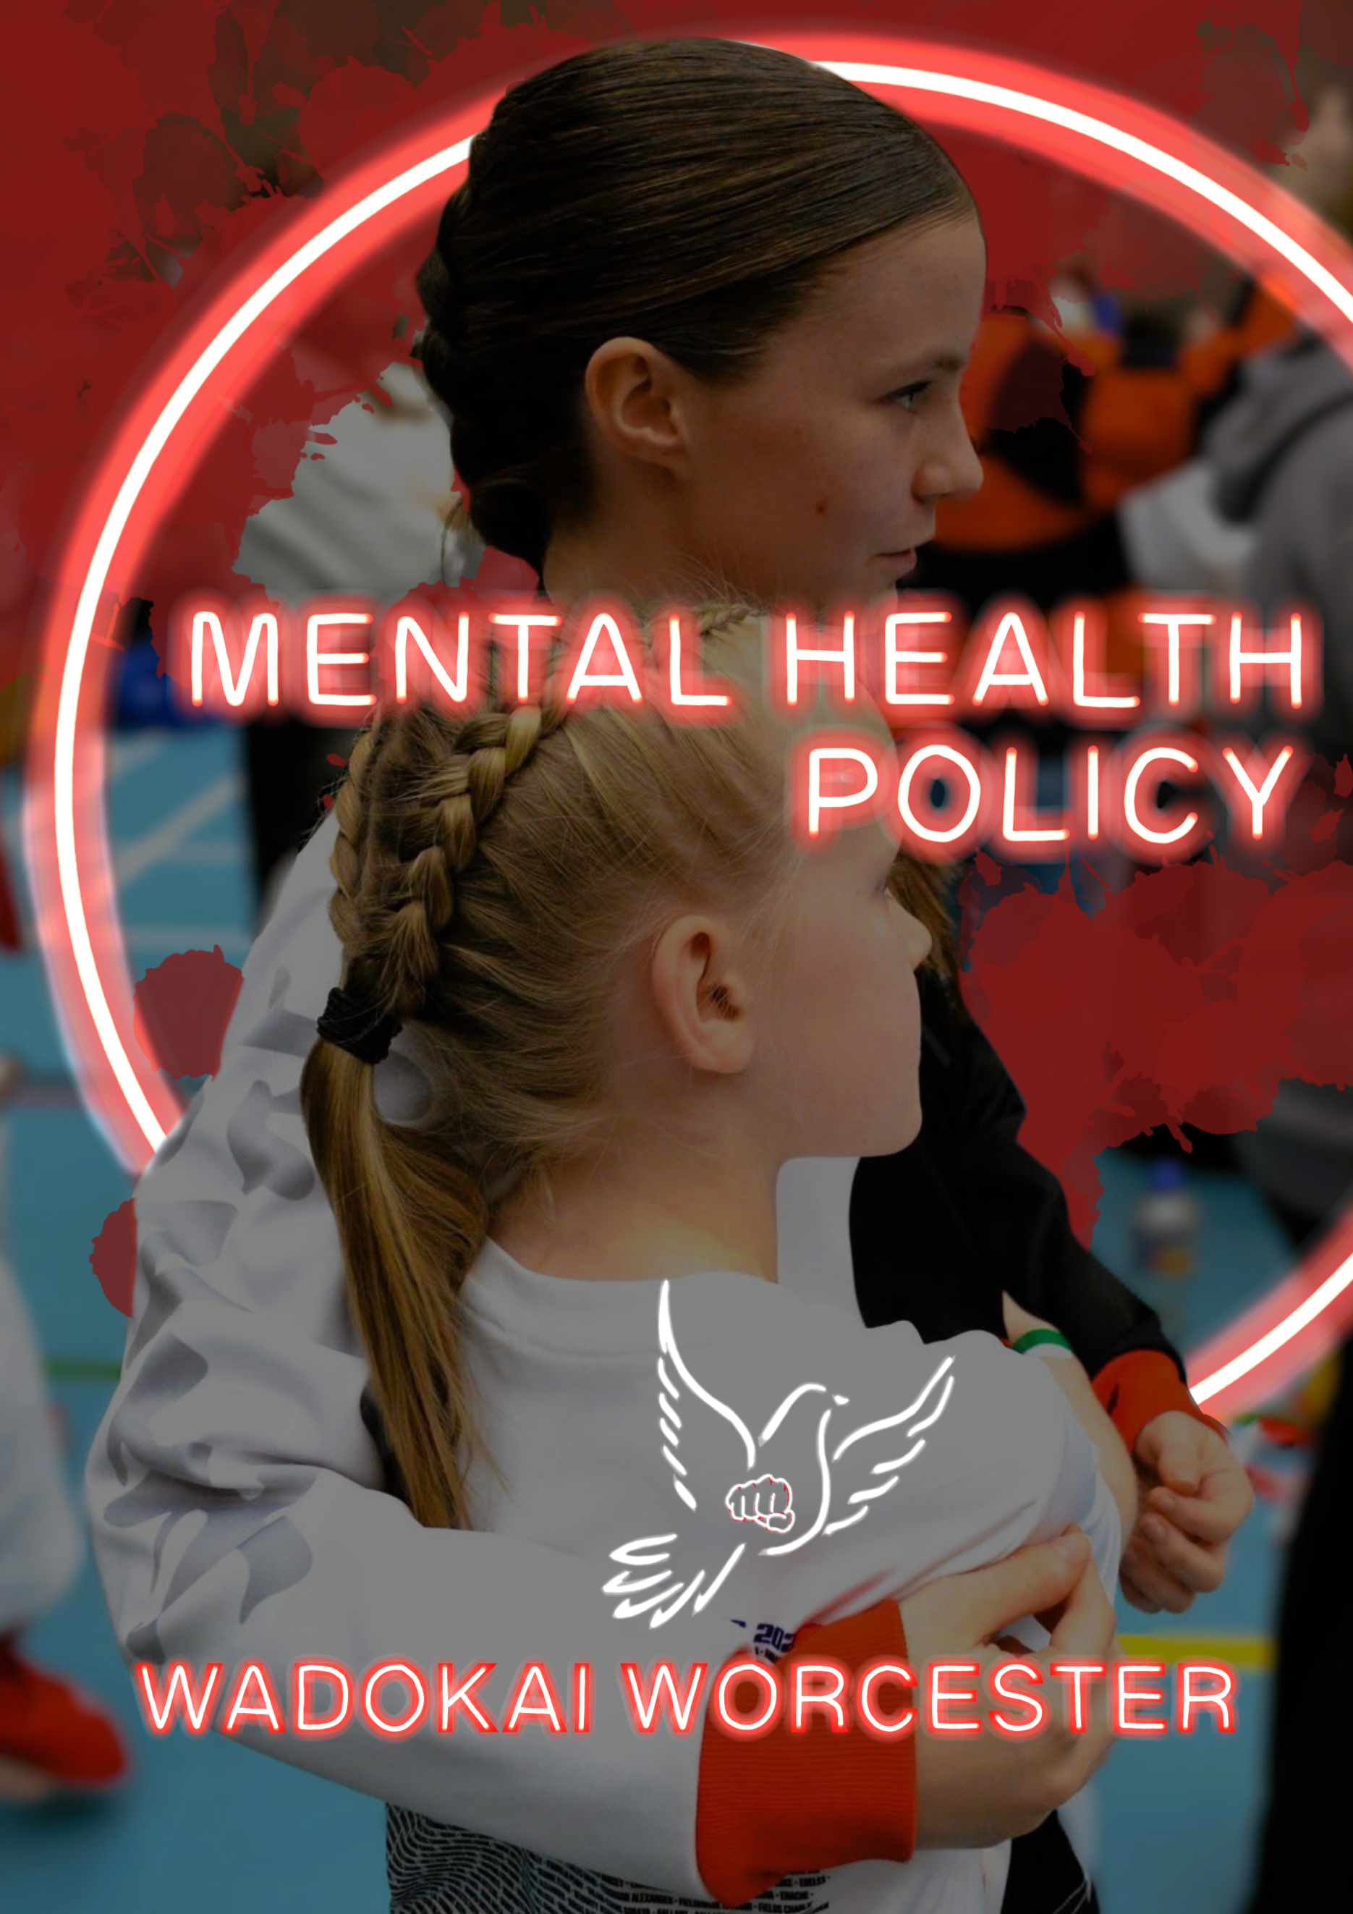

WadoKai Worcester Karate Mental Health First Aid Policy
1. Policy Statement
WadoKai Worcester Karate is committed to promoting the mental well-being of all members, instructors, and staff. This policy outlines our approach to mental health first aid, ensuring that appropriate measures are in place to support individuals experiencing mental health crises while maintaining professional boundaries. Please note that coaches and volunteers within the club are not Mental Health professionals so will be unable to offer advise. However, should an incident be deemed sever mental health services may be contacted.

2. Purpose
The purpose of this policy is to:
- Ensure that mental health emergencies are recognised and responded to appropriately.
- Provide clear procedures for handling mental health crises, including panic attacks, trauma responses, suicidal thoughts, and self-harm incidents.
- Define roles and responsibilities in managing mental health situations.
- Promote a safe and supportive environment for all members.

3. Scope
This policy applies to all members, instructors, staff, volunteers, and visitors at WadoKai Worcester Karate. It covers all club-related activities, including training sessions, competitions, and events.

4. Recognising Mental Health Emergencies
A mental health emergency is any situation where an individual is experiencing extreme distress, is at risk of harming themselves or others, or is unable to function due to a crisis.
Common mental health emergencies include:
- Panic attacks (e.g., rapid breathing, palpitations, extreme distress).
- Dissociation or trauma responses (e.g., unresponsiveness, detachment).
- Suicidal ideation (e.g., expressing thoughts of self-harm or suicide).
- Self-harm incidents (e.g., visible injuries or active self-harm).
- Severe emotional breakdowns (e.g., uncontrollable crying, hyperventilation, aggression).
All club staff and instructors must be able to recognise these situations and respond appropriately.

5. Roles and Responsibilities
To ensure a structured and effective response, the following roles and responsibilities apply:
- Club Owner/Lead Instructor: Ensures mental health policies are implemented and adhered to.
- Mental Health First Aider (if available): Provides immediate support and follows crisis procedures.
- Assistant Instructors/Senior Members: Help manage the environment while a crisis is handled.
- Emergency Contact Liaison: Responsible for contacting emergency services or next of kin when necessary.

6. Response to Mental Health Emergencies
6.1 Handling a Panic Attack
- Move the individual to a quiet and private space.
- Encourage slow, deep breathing (e.g., 4-7-8 breathing technique).
- Use grounding techniques (e.g., 5-4-3-2-1 sensory method).
- Reassure them that they are safe and the panic attack will pass.
- Allow them to return to activity only when they feel ready.
6.2 Responding to Suicidal Thoughts
- Take any mention of suicide seriously.
- Listen calmly and without judgment.
- Ask directly: “Are you thinking about ending your life?”
- Do not leave the individual alone.
- Contact the safeguarding officer, emergency contact, or emergency services if the risk is immediate.

6.3 Managing an Emotional Breakdown or Trauma Response
- Provide a quiet space for the individual to recover.
- Encourage slow, deep breathing to regulate emotions.
- Avoid physical contact unless the individual explicitly requests it.
- Use calm, supportive language to reassure them.
- Offer them an option to leave discreetly if necessary.
6.4 Responding to Self-Harm Incidents
- Administer first aid if there is an open wound.
- Avoid reacting with shock or anger.
- Ask if they are receiving support and provide information on available services.
- If injuries are severe or indicate a significant crisis, contact emergency services.

7. Confidentiality and Safeguarding
WadoKai Worcester Karate is committed to handling mental health matters with sensitivity and confidentiality. Any discussions regarding a member’s mental health will be kept confidential, except where there is a risk of harm, in which case appropriate authorities or emergency contacts may be informed.
Key safeguarding principles:
- Confidentiality will be maintained unless there is a risk of harm.
- All instructors and staff must follow safeguarding procedures.
- Records of any mental health incidents must be documented securely.

8. Preventative Measures
To promote mental well-being and reduce the risk of crises, WadoKai Worcester Karate will:
- Provide mental health awareness training to instructors and staff.
- Encourage open discussions about mental well-being.
- Ensure members know where to access mental health support services.
- Provide a quiet space for individuals to take a break if needed. (If the venue has this space available)

9. Implementation and Review
This policy will be reviewed annually to ensure it remains effective and up to date. Any necessary amendments will be made to reflect changes in best practices and legal requirements.

For any concerns regarding mental health first aid at WadoKai Worcester Karate, please contact katrinajaywilson@gmail.com.

