WADOKAI WORCESTER / WORCESTERSHIRE KARATE SQUAD
SAFEGUARDING TEAM

Children’s Safeguarding Policy

Document type: | Policy
Version: | 2.1
Author: | Katrina Wilson
Validated by: | Safeguarding Team
Date Validated: | September 2023
Date uploaded to internet: | September 2023
Review Date: | October 2024

Version control

Version | Type of change | Date | Revisions Made
1.0 | New Document | May 2018 | N/a
2.0 | Minor revisions | June 2020 | Update of contact details and safeguarding flowchart.
2.1 | Major amendments | September 2023 | Safeguarding areas previously omitted now included. These areas are:  - Prevent section with flowchart to assist with escalation of concerns.  - FGM (including breast ironing)  GDPR

WADOKAI WORCESTER / WORCESTERSHIRE KARATE SQUAD
SAFEGUARDING TEAM

Section  Number | Title | Pages
1. | Introduction | 3
2. | Policy Statement | 3
3. | Policy aims | 4
4. | Promoting good practice | 4
5. | Good practice guidelines | 5
6. | Practices to be avoided | 6
7. | Practices never to be sanctioned | 7
8. | Incidents that must be reported/recorded | 7
9. | Defining child abuse | 8
10. | Common signs of abuse | 8
11. | Children with additional needs | 9
12. | Children from Ethnic Minority Backgrounds | 10
13. | Prevent | 10
14. | Female Genital Mutilation (FGM) | 13
15. | Breast Flattening/Ironing | 14
16. | Responding to suspicions or allegations | 15
17. | Confidentiality | 16
18. | Internal Inquiries and suspension | 16
19. | Support to deal with the aftermath of abuse | 17
20. | Allegations of Previous Abuse | 17
21. | Action if bullying is suspected | 17
22. | Information for social services or the police about suspected abuse | 18
23. | Responding to the child | 20
24. | Safeguarding and overnight trips for competitions | 20
25. | GDPR | 21
Appendixes
1 | Prevent reporting flowchart | 22
2 | FGM Reporting flowchart | 23
3 | Child Safety and welfare concern flowchart | 24
4 | Useful contacts | 26

- Introduction

  - WadoKai Worcester recognises the need to make provision for children and young persons, and acknowledges its moral and legal responsibility to ensure that:

- The welfare of the child is paramount
- All children, whatever their age, culture, disability, gender, language, racial origin religious beliefs and/or sexual identity have the right to protection from abuse;
- All suspicions and allegations of abuse will be taken seriously and responded to swiftly and appropriately
- All staff (paid /unpaid) working within our sport have a responsibility to report concerns to the appropriate officer

1.2 The Children’s Act 1989 defines a child as a person under the age of 18.

1.3 Adopting best practice will help to safeguard those participants from potential abuse as well as protecting coaches and other adults in positions of responsibility from any potential allegation of abuse.

1.4 This document is binding and provides procedures and guidance to everyone within WadoKai Worcester Karate, whether working in a voluntary or professional capacity.

- Policy Statement

2.1 WadoKai Worcester has a duty of care to safeguard all children involved in all forms of Karate from harm.

2.2 All children have a right to protection, and the needs of disabled children and others who may be particularly vulnerable must be taken into account. As such WadoKai Worcester will strive to ensure the safety and protection of all children involved in our sport through adherence to the Child Protection guidelines ratified and adopted by WadoKai Worcester and approved by Sport England and the NSPCC Child Protection in Sport Unit.

2.3 Sport can and does have a very powerful and positive influence on people especially young people. Not only can it provide opportunities for enjoyment and achievement; it helps to develop and enhance valuable qualities such as self-esteem, leadership and teamwork. WadoKai Worcester have to ensure that for those positive experiences to take place that sport in the hands of those who have the welfare of young people uppermost in their mind and that we have proper procedures and practices to support and empower them.

- Policy aims

  - The aim of the Child Protection Policy is to promote good practice:

- Providing children and young persons with appropriate safety and protection whilst in the care of WadoKai Worcester Karate

- Ensure that all incidents of poor practice and allegations of abuse will be taken seriously and responded to swiftly and appropriately

- Allow all staff /volunteers to make informed and confident responses to specific child protection issues.

- The policy recognises and builds on the legal and statutory definition of a child.

- The distinction between ages of consent, civil and criminal liability are recognised but in the pursuit of good in the delivery and management of WadoKai Worcester, a young person is recognised as being under the age of 18 years [Children’s Act 1989].

- Confidentiality will be upheld in line with the Data Protection Act 1984, the Human Rights Act 2000 and the WadoKai Worcester Whistle Blower’s Policy

- Promoting Good Practice

  - Child abuse, particularly sexual abuse, can arouse strong emotions in those facing such a situation. It is important to understand these feelings and not allow them to interfere with a judgement about the appropriate action to take.

4.2 Abuse can occur within many situations including the home, school and the sporting environment. It is a fact of life that some individuals will actively seek employment or voluntary work with young people in order to harm them. A coach, instructor, teacher, official or volunteer may have regular contact with young people and be an important link in identifying cases where a young person needs protection. All cases of poor practice should be reported to following the guidelines in this document. When a child enters the club having experienced abuse outside the sporting environment, sport can play a crucial role in improving the child’s self esteem. In such instances the club must work with the appropriate agencies to ensure the child receives the required support.

- Good Practice Guidelines

  - All those involved in Martial Arts should be encouraged to demonstrate exemplary behaviour in order to safeguard children and young people and protect themselves from false allegations. The following are common sense examples of how to create a positive culture and climate within Martial Arts:

  - Good practice means:
- Always working in an open environment (e.g. avoiding private or unobserved situations and encouraging open communication).
- Treating all young people/disabled adults equally, and with respect and dignity.
- Placing the welfare and safety of the child or young person first above the development of performance or competition.
- Maintaining a safe and appropriate distance with players (e.g. it is not appropriate to have an intimate relationship with a child or to share a room with them)
- Building balanced relationships based on mutual trust, which empowers children to share in the decision-making process
- Making sport fun, enjoyable and promoting fair play
- Where any form of manual or physical support is required, it should be provided openly and in accordance with WadoKai Worcester Guidelines
- Keeping up to date with the technical skills, qualifications and insurance within Karate.
- Involving parents/carers wherever possible (e.g. for the responsibility of their children in the changing rooms). If groups have to be supervised in the changing rooms, always ensure parents/teachers/coaches/officials work in pairs.
- Ensuring when mixed teams are taken away, they should always be accompanied by male and female member of staff (NB however, same gender abuse can also occur).
- Ensuring that at tournaments or residential events, adults should not enter children’s rooms or invite children into their rooms
- Being an excellent role model – this includes not smoking or drinking alcohol in the company of young people.
- Giving enthusiastic and constructive feedback rather than negative criticism
- Recognising the developmental needs and capacity of young people and disabled adults – avoiding excessive training or competition and not pushing them against their will.

  - Martial Arts Instructors need to understand the added responsibilities of teaching children and also basic principles of growth and development through childhood to adolescence. Exercises should be appropriate to age and build. Instructors should not simply treat children as small adults, with small adult bodies.
- There is no minimum age for a child beginning Martial Arts, as the build and maturity of individuals varies so much. However the nature of the class must be tailored to consider these factors
- In general, the younger the child, the shorter the attentions span. One hour is generally considered sufficient training time for the average 12 year old or below. Pre-adolescent children have a metabolism that is not naturally suited to generating anaerobic power, and therefore they exercise better aerobically, that is, at a steadily maintained rate. However, they can soon become conditioned to tolerate exercise in the short explosive bursts that more suit Karate training.
- Children should not do assisted stretching - they generally don’t need to, and there is a real risk of damage with an inconsiderate or over-enthusiastic partner.
- Children should be carefully matched for size and weight for sparring practice
- Great care must be taken, especially where children train in the proximity of adults, to avoid collision injury
- Children should not do certain conditioning exercises; especially those, which are heavy, load bearing, for example weight training or knuckle push-ups. Children should not do any heavy or impact work but should concentrate on the development of speed, mobility, skill and general fitness.
- No head contact is permitted for children participating in kumite or partner work due to significant, evidenced based health concerns surrounding the impacts of concussion.

- Practices to be avoided

  - The following should be avoided except in emergencies. If a case arises where these situations are unavoidable (e.g. the child sustains an injury and needs to go to hospital, or a parent fails to arrive to pick a child up at the end of a session), it should be with the full knowledge and consent of someone in charge in the club or the child’s parents. Otherwise, avoid:

- Spending excessive amounts of time alone with children away from others.
- Taking or dropping off a child to an event.

  - WadoKai Worcester follows the guidance set forth by the NSPCC Safe Sports Events document and in doing so have drawn up a document for parents to sign and complete prior to any event. (This may be found……) The guidance covers – Transport arrangements, travel checklists, supervision and staffing, emergency procedures, insurance special overnight arrangements and any special health requirements as well as an athlete wellness check prior to competing.

  - The following should be avoided except in emergencies. If cases arise where these situations are unavoidable, they should only occur with the full knowledge and consent of someone in charge in the club or the child’s parents. For example, a child sustains an injury and needs to go to hospital, or a parent fails to arrive to pick a child up at the end of a session.
- Spending excessive amounts of time alone with children away from others.
- Taking or dropping off a child to a venue

- Practices never to be sanctioned

7.1 The following should never be sanctioned. You should never:
- Engage in rough, physical or sexually provocative games, including horseplay
- Share a room with a child
- Allow or engage in any form of inappropriate touching
- Allow children to use inappropriate language unchallenged
- Make sexually suggestive comments to a child, even in fun
- Reduce a child to tears as a form of control
- Allow allegations made by a child to go unchallenged, unrecorded or not acted upon
- Do things of a personal nature for children or disabled adults that they can do for themselves
- Invite or allow children to stay with you at your home unsupervised

NB. It may sometimes be necessary for staff or volunteers to do things of a personal nature for children, e.g. if they are young or are disabled. These tasks should only be carried out with the full understanding and consent of parents and the players. If a person is fully dependent on you, talk with him/her about what you are doing and give choices where possible. This is particularly so if you are involved in any dressing or undressing of outer clothing, or where there is physical contact, lifting/assisting to carry out particular activities. Avoid taking on the responsibility for tasks for which you are not appropriately trained.

- Incidents that must be reported / recorded:

8.1 If any of the following occur you should report this immediately to another colleague and record the incident. You should also ensure the parents of the child are told if:
- You accidentally hurt a child or young person
- He/she seems distressed in any manner.
- A student appears to be sexually aroused by your actions.
- A child or young person misunderstands or misinterprets something you have done.

- Defining Child Abuse

  - Child abuse is when a child or young person is harmed by another person. There are 4 main type of abuse:

- Physical abuse: This includes being hit, kicked, shaken or punched, or given harmful drugs or alcohol

- Emotional abuse: This includes being called names all the time, being threatened or being shouted at or made to feel small. Bullying is also a form of abuse. Bullying includes hitting or threatening a child with violence, taking their things, calling them names or insulting them, making/encouraging them do things they won't want to do (peer pressure is also included), and deliberately humiliating or ignoring them.

- Sexual abuse: This includes being touched in a way you don't like by an adult or young person, being forced to have sex- rape, assault by penetration and sexual assault, or being made to look at sexual pictures or videos- Sexual Harassment, such as sexual comments, remarks, jokes, online sexual harassment, upskirting or sexting . For some disabled children, it includes if a person helping them to use the toilet touched them more than was needed.

- Neglect: Is when a child is not looked after properly, including having no place to stay, or not enough food to eat, or clothes to keep them warm. It also includes if the child is not given medical care when they need it, including medication. For some disabled children, it could include if their carer took away the things they needed for everyday life - like their wheelchair or communication board. Or not helping a disabled child who needed help using the toilet.

- Common signs of abuse

10.1 Every child is unique, so behavioural signs of abuse will vary from child to child. In addition, the impact of abuse is likely to be influenced by the child's age, the nature and extent of the abuse, and the help and support the child receives. However, there are some behaviours that are commonly seen in children and young people who have been abused:
- The child appears distrustful of a particular adult, or a parent or a coach with whom you would expect there to be a close relationship.
- He or she has unexplained injuries such as bruising, bites or burns - particularly if these are on a part of the body where you would not expect them.
- If he or she has an injury which is not explained satisfactorily or properly treated.
- Deterioration in his or her physical appearance or a rapid weight gain or loss.
- Pains, itching, bruising, or bleeding in or near the genital area
- A change in the child's general behaviour. For example, they may become unusually quiet and withdrawn, or unexpectedly aggressive. Such changes can be sudden or gradual.
- If he or she refuses to remove clothing for normal activities or wants to keep covered up in warm weather
- If he or she shows inappropriate sexual awareness or behaviour for their age.
- Some disabled children may not be able to communicate verbally about abuse that they may be experiencing or have witnessed. It is therefore important to observe these children for signs other than 'telling'

10.2 These signs should be seen as a possible indication of abuse and not as a confirmation. Changes in a child’s behaviour can be the result of a wide range of factors.

10.3 Visible signs such as bruising or other injuries cannot be taken as proof of abuse. For example some disabled children may show extreme changes in behaviour, or be more accident prone, as a result of their impairment. A child or young person may also try to tell a person directly about abuse. It is very important to listen carefully and respond sensitively. WadoKai Worcester Karate has a responsibility to act on any concerns.
- Children with additional needs
11.1 WadoKai Worcester recognise that children with either a physical or mental diversity are more prone to being abused than other children. They are more likely to be abused as a consequence of the following:
- Vulnerabilities to bullying from other children and adults
- Likely to be more socially isolated and have less frequent contact than children without disabilities
- Dependency on others for assistance in order to carry out essential daily tasks
- The inability or a difficulty in expressing themselves and communicating that abuse has taken place
- Impaired capacity to resist and understand abuse
11.2 It is the responsibility of all to ensure that the duty of care to children is upheld at all times and in order to bring about an inclusive environment for all children there are areas of good practice which will need to be taken into consideration.
11.3 At WadoKai Worcester in order to aid in any potential barriers we insist that the parent/caregiver joins alongside to provide any additional support that child may need. Being a small local club, we cannot provide services for every need, however aim to make reasonable adjustments when possible.

- Children from Ethinic Minority Backgrounds
12.1 Children from ethnic minority backgrounds are more susceptible to being abused for the following reasons:
- Language difficulties may make it difficult for the child to tell somebody that they are being abused
- Children may be more socially isolated and have less contact with people from outside their community
- Stereotyping or prejudice may lead to situations where abuse is not detected or is misinterpreted
- Children may be more prone to being victims of discrimination and bullying
12.2 In order to ensure that children from ethnic minority backgrounds are adequately safeguarding religious festivals and/or daily practices should be considered. For example a child who is fasting during the festival of Ramadan may be more physically exhausted than usual and therefore due consideration ought to be given when training.
12.3 Moreover, to be as inclusive as possible it is advised that events – where possible – are not held on days which coincide with significant religious or cultural feast days. Some religions and cultures may also adhere to strict dietary requirements and therefore when planning things like team meals or catering for presentation nights for example, these dietary requirements should be taken into consideration e.g. vegetarian, halal, kosher.
13. Prevent
  - WadoKai Worcester along with the EKF is committed to playing an active role in the Government’s anti- terrorism strategy CONTEST which involves the programme PREVENT. The EKF recognise that the principles of the Governing Body and of karate itself - including teamwork, respect, discipline and sportsmanship - can act as fundamental building blocks to preventing radicalisation at every level. This in turn allows children from diverse backgrounds to reach their full potential within the sport.

  - As of July 2015 all schools and childcare providers under Section 26 of the Counter Terrorism and Security Act 2015 were mandated by law to pay due regard to the prevention of young people being radicalised and recruited to terrorism. Whilst this legislation is targeted specifically at schools all agencies which come into contact with children and young people must also seek to prevent radicalisation. The Prevent strategy links closely with WadoKai Worcester’s duty of care to look after the health and wellbeing of all children within our club.

  - It is important to note that the general risks surrounding radicalisation of children and young people varies geographically and by age group. As members of WadoKai Worcester who have a wide range of involvement with children and young people we are uniquely placed to identify and respond to any risks within a local context. It is crucial to understand the risks in order to be able to respond appropriately and proportionately.
The strategy and its aims:
  - CONTEST is based around four key work streams which are aimed at reducing the risk to the United Kingdom. These four key work streams are:
- Pursue: Stop terrorist attacks from occurring
- Prevent: Stop people from becoming terrorist or supporting terrorist organisations/cells
- Protect: Strengthen protection against terrorism and any actions thereof
- Prepare: Mitigate any impact of terrorism and any actions thereof
  - Prevent is a strategy which is adopted throughout a wide range of organisations encompassing both the public sector and private sector as well as charitable organisations and voluntary groups. The Prevent initiative has three distinct objectives which include:
- Respond to the ideological challenges posed by terrorism and the threat from proponents of terrorism
- Deter people from being dram into terrorism initially
- Work collaboratively with institutions and wider society to address the risk of radicalisation.
13.6 The overarching aim of Prevent it to safeguard/protect individuals who may be vulnerable to radicalisation. Radicalisation against terrorism is not exclusive to one brand of terrorism and crosses the political and religious spectrum.
The Exploitation Process
13.7 It is universally acknowledged that there are no one set of circumstances which can explain why vulnerable people become involved in terrorism however it is widely understood that personal experiences affect the ways in which vulnerable individuals deal with their external environments. The factors are likely to be personal and unique from child to child. Radicalisers who attempt to convert children and young people to their cause will often prey upon somebodies vulnerabilities. Contact between the vulnerable child/young person and the radicaliser can also take many forms from face to face contact to social networking and other forms of media but often through a combination of methods. Nonetheless, it is more commonplace for those who are vulnerable to become involved in terrorism and related activities through the influence of their family and peer group and it therefore takes on a distinctly social element.

13.8 Whilst the social element cannot be discounted, the internet is increasingly playing a part in radicalisation as it provides a platform for the promotion of terrorist related propaganda to a wide audience at the click of a button. Members should therefore be mindful of any content which romanticises violence or makes apologies for terrorism being shared and discussed by students either online, at classes or away on competition.
Factors Affecting Vulnerability
13.9 As already acknowledged there is no defined criterion which constitutes vulnerability however the following circumstances – when taken in conjunction – may be indicative of radicalisation:
- Identity crisis
- Personal crisis
- Personal Circumstances
- Criminality
- The internet, social networking and other media
- Personal grievances
13.10 The principle of dealing with Prevent related risks is the same as managing other safeguarding risks. All members who have contact with children should be alert to any changes in a child’s behaviour which could be indicative that they require protection
13.11 Whilst any radicalisation signs may differ greatly from one child to another (with children also known to hide their views) this policy does not require WadoKai Worcester officials, instructors or associations to undertake intrusive interventions into family life but to take action when potentially concerning behaviour has been identified.
13.12 However, there is no obligation or expectation that the EKF or Association members will take on a surveillance or enforcement role rather any concerns should be flagged to the relevant Child Protection Lead, who will then liaise with partner organisation in order to contribute to the prevention of terrorism and making safety a shared endeavour. Please see Appendix 1 for more information.
Human Rights Act
13.13 In addition to the Equality Impact Assessment accompanying this policy, it is also the view of the Safeguarding Team that this section of the policy does not bare any Human Rights related issues as it simply follows national guidance laid down by the UK Government. However, due care and attention should be carried out when implementing the policy and acting upon any concerns as not to discriminate.

14. Female Genital Mutilation (FGM)
14.1 FGM is the practice of intentionally removing part or all of the external female genitalia and/or other female genital organ injury for non-medical purposes with FGM having no health benefits. FGM may also be referred to as ‘female circumcision’ or ‘cutting’ and in diverse communities cultural references may be used which may be include; tahur, halalays, gudniin, sunna or khitan to name but a few.
14.2 The practice is a cultural one with no religious text requiring that girls are ‘cut’. It is most prevalent in African and Middle Eastern regions but it is not exclusively geographically defined. The countries with the highest prevalence of the practice include Egypt, Eritrea, Ethiopia, Gambia, Guinea, Nigeria and Somalia. The practice is also carried out in Asian countries such as Malaysia and has been known to occur in South America. Whilst these countries have the highest prevalence of the practice, it is carried out on British citizen when parents take their child abroad.
14.3 There is no one way of undertaking the ‘cut’ and it can be carried out at a number of differing stages from two days after birth to before puberty or even during pregnancy. The age group which is most commonly affected ranges from 0-15 years.
14.4 This is an inhumane treatment which has been outlawed in the UK through the FGM Act 2003 and anybody who has been found guilty of the offence can face up to 14 years in jail. Additionally anybody found to be failing in their duty of care and assumed responsibility e.g. a parent, who allows the practice to happen to their daughter can face up to 7 years in prison. The practice results in severe bleeding and problems during urination as well as infections, child- birth complications and the increased chance of infant mortality not to men- tioned psychological problems.
14.5 Given these procedures are not fully irreversible, prevention is key. WadoKai Worcester have a duty of care to the children they come into contact with and if signs and symptoms are identified it is imperative that action is taken to either to bring about justice before or after the practice has occurred.
14.6 Key signs and symptoms to be mindful of:
- The child’s relatives are known to have had FGM
- The family belongs to a community which is known to practice FGM (Culteral appropriations are not sufficient grounds for concern and accusations based solely upon cultural heritage should be discouraged. However, when taking into account other factors this may be a genuine cause for concern
- The child will be absent from training for a number of weeks as they are planning on making a trip to one of the countries previously identified (Note this of itself is not a cause of concern and should be taken into consideration with other factors)
- You are involved is discussions with the child who discloses that they have a forthcoming special celebration
- You notice that the child has difficulty walking or sitting. The child may alsi be unable to vary out certain karate techniques or stretching/warm up exercises as they once did.
  - For further advice and guidance on FGM there is a free online course offered by the Home Office on FGM. This can be accessed by following the below link:
https://www.virtual-college.co.uk/resources/free-courses/recognising-and-preventing-fgm
15. Breast Flattening/Ironing
15.1 The terms breast flattening and breast ironing are used to refer to the procedure whereby young pubescent girls’ breasts are – over a period of time including years – flattened and/or pounded down. The purpose of this is to delay the development of breasts entirely or to make the breasts permanently disappear.
15.2 The practice is usually done within families (often by female relatives) and in- volves large stones, hammers or spatulas being heated up over scorching hot coals to compress breast tissue. Other methods adopted can include the use of a binder or elastic belt to press the breasts.
15.3 It is something which usually starts when the girl first shows signs of puberty and can be as young as 9 years old.
  - Breast ironing and flattening may also be done by the child themselves as they may be undergoing gender transformation/identity issues.
  - Based upon research carried out by the National FGM Centre in the UK, it was found that the practice is largely confined to the African continent or those with African heritage with Cameroon being identified as one of the ar- eas where this is most prevalent. Other countries known to carry out the pro- cedure include Benin, Chad, Kenya, South Africa, Togo and Zimbabwe.
15.6 The health implications of such a practice, both physical and mental, can be extremely damaging with abscesses, severe fever and infections common place
  - Unlike FGM, there is no specific law which addresses the issue but it falls under the category of physical abuse and should be dealt with as such. However, like FGM, the processes and procedures to follow if you identify or have suspicions that the practice has taken place are the same.
Signs and symptoms to look out for:
15.8 Signs and symptoms should be treated with caution and used in conjunction with other known facts or other signs and symptoms. For example a girl may be embarrassed about her body for other reasons such as body confidence and is of itself not indicative that abuse has occurred. These signs may be noticed during karate sessions when a girl is changing before or after practice or when discussing with fellow students before, during or after sessions.
15.9 The main signs to look out for include:
- A girl being embarrassed about their body
- A girl is born to a woman who has undergone breast flattening or members of the girls immediate family have
- References to breast flattening in conversation
- The girl’s family have limited levels of integration within the wider community
  - Documented in Appendix 2 is a flowchart for how you would report suspicions of FGM and/or Breast Flattening/Ironing.
16. Responding to suspicions or allegations
16.1 It is not the responsibility of anyone working for WadoKai Worcester, in a paid or unpaid capacity to decide whether or not child abuse has taken place. This is the role of the child protection agencies. However, there is a responsibility for all involved in Martial Arts to act on any concerns through contact with the appropriate authorities. Advice and information is available from the local Social Services Department, The Police or the NSPCC 24 hour Help line 0808 800 5000. WadoKai Worcester assures all staff/volunteers that it will fully support and protect anyone, who in good faith reports his or her concern that a colleague is, or may be, abusing a child. Where there is a complaint against a member of staff there may be three types of investigation
- A criminal investigation
- A child protection investigation
- A disciplinary or misconduct investigation
  - The results of the Police and child protection investigation may well influence the disciplinary investigation, but not necessarily. Action Concerns about poor practice:
- If, following consideration, the allegation is clearly about poor practice, the Child Protection Officer will deal with it as a misconduct issue
- If the allegation is about poor practice by the Child Protection Officer, or if the matter has been handled inadequately and concerns remain, it should be reported to the relevant officer who will decide how to deal with the allegation and whether or not to initiate disciplinary proceedings.
16.3 Concerns about suspected abuse
- Any suspicion that a child has been abused by either a member of staff or a volunteer should be reported to the Child Protection Officer, who will take such steps as considered necessary to ensure the safety of the child in question and any other child who may be at risk. An incident reporting form can and other resources can be found in Appendix 3, 4 and 5.
- The Child Protection Officer will refer the allegation to the social services department, which may involve the Police, or go directly to the Police if out-of- hours.
- The parent or carers of the child will be contacted as soon as possible following the advice from the social services department.
- The Child Protection Officer should also notify the relevant Association Child Protection Officer who in turn will inform the EKF Lead Child Protection Officer who will deal with any media enquiries.
- If the Child Protection Officer is the subject of the suspicion/allegation, the report must be made to the appropriate Manager or in his/her absence the EKF Lead Child Protection Officer who will refer the allegation to social services.
17. Confidentiality

17.1 Every effort should be made to ensure that confidentiality is maintained for all concerned. Information should be handled and disseminated on a need to know basis only.
This includes the following people:
- The Child Protection Officer
- Lead Child Protection Officer
- The parents of the person who is alleged to have been abused
- The person making the allegation
- Social services/police
- The alleged abuser (and parents if the alleged abuser is a child).
Seek social services advice on who should approach the alleged abuser.

Information should be stored in a secure place with limited access to designated people, in line with data protection laws (e.g. that information is accurate, regularly updated, relevant and secure).

18. Internal Inquiries and suspension

18.1 All internal inquiries relating to Safeguarding will be overseen by the Lead Child Protection Officer of WadoKai Worcester Karate suspension/s will be addressed in accordance with, WadoKai Worcester Karate Discipline Policy
  - The welfare of the child should remain of paramount importance throughout.

19. Support to deal with the aftermath of abuse

19.1 Consideration should be given to the kind of support that children, parents and members of staff may need. Use of helplines, support groups and open meetings will maintain an open culture and help the healing process.
19.2 The British Association for Counselling Directory is available from The British Association for Counselling, 1 Regent Place, Rugby CV21 2PJ, Tel: 01788 550899, Fax: 01788 562189, Email: bac@bacp.co.uk, Internet: www.bacp.co.uk
19.3 Consideration should be given to what kind of support may be appropriate for the alleged perpetrator

20. Allegations of previous abuse

20.1 Allegations of abuse may be made some time after the event (e.g. by an adult who was abused as a child or by a member of staff who is still currently working with children). Where such an allegation is made, the club should follow the procedures as detailed above and report the matter to the social services or the police. This is because other children, either within or outside sport, may be at risk from this person. Anyone who has a previous criminal conviction for offences related to abuse is automatically excluded from working with children. This is reinforced by the details of the Protection of Children Act 1999.

21. Action if bullying is suspected

21.1 If bullying is suspected, the same procedure should be followed as set out in 'Responding to suspicions or allegations' above.

21.2 Action to help the victim and prevent bullying in sport:
- Take all signs of bullying very seriously.
- Encourage all children to speak and share their concerns (It is believed that up to 12 children per year commit suicide as a result of bullying, so if anyone talks about or threatens suicide, seek professional help immediately). Help the victim to speak out and tell the person in charge or someone in authority.
- Investigate all allegations and take action to ensure the victim is safe. Speak with the victim and the bully (ies) separately.
- Reassure the victim that you can be trusted and will help them, although you cannot promise to tell no one else.
- Keep records of what is said (what happened, by whom, when).
- Report any concerns to the Child Protection Officer or the school (wherever the bullying is occurring).
21.3 Action towards the bully (ies)
- Talk with the bully (ies), explain the situation, and try to get the bully(ies) to understand the consequences of their behaviour. Seek an apology to the victim(s).
- Inform the bully (ies)’s parents.
- Insist on the return of 'borrowed' items and that the bully (ies) compensate the victim.
- Provide support for the victim's coach.
- Impose sanctions as necessary
- Encourage and support the bully (ies) to change behaviour.
- Hold meetings with the families to report on progress.
- Inform all organisation members of action taken.
- Keep a written record of action taken.
21.4 Concerns outside the immediate sporting environment (e.g. a parent or carer):
- Report your concerns to the Child Protection Officer, who should contact social services or the police as soon as possible.
- See 4. Below for the information social services or the police will need.
- If the Child Protection Officer is not available, the person being told of or discovering the abuse should contact social services or the police immediately.
- Social services and the Child Protection Officer will decide how to involve the parents/carers.
- Maintain confidentiality on a need to know basis only.

22. Information for social services or the police about suspected abuse:

22.1 To ensure that this information is as helpful as possible, a detailed record should always be made at the time of the disclosure/concern, which should include the following:
- The child's name, age and date of birth of the child
- The child's home address and telephone number
- Whether or not the person making the report is expressing their own concerns or those of someone else.
- The nature of the allegation. Include dates, times, any special factors and other relevant information.
- Make a clear distinction between what is fact, opinion or hearsay.
- A description of any visible bruising or other injuries. Also any indirect signs, such as behavioural changes
- Details of witnesses to the incidents.
- The child’s account, if it can be given, of what has happened and how any bruising or other injuries occurred.
- Have the parents been contacted?
- If so, what has been said?
- Has anyone else been consulted? If so, record details.
- If the child was not the person who reported the incident, has the child been spoken to? If so, what was said?
- Has anyone been alleged to be the abuser? Record details
- Where possible referral to the police or social services should be confirmed in writing within 24 hours and the name of the contact who took the referral should be recorded.

22.2 If you are worried about sharing concerns about abuse with a senior colleague, you can contact social services or the police direct, or the NSPCC Child Protection Helpline on 0808 800 5000, or Childline on 0800 1111.
22.3 False allegations of abuse do occur, but they are rare. You should always take immediate action if a child says or indicates that he or she is being abused, or you have reason to suspect that this is the case. This may involve dealing with the child, his parent or carer, colleagues at your club / organisation, teachers, external agencies or the media. Children who are being abused will only tell people they trust and with whom they feel safe. As a coach you will often share a close relationship with students and may therefore be the sort of person in whom a child might place their trust
22.4 Children want the abuse to stop. By listening and taking what a child is telling you seriously, you will already be helping to protect them. It is useful to think in advance about how you might respond to this situation in such a way as to avoid putting yourself at risk
Timing and Location
22.5 It is understandable that the child may want to see you alone, away from others. The child may therefore approach you at the end of a session when everyone is going home, or may arrive deliberately early at a time when they think you will not be busy. However, a disclosure is not just a quick chat; it will take time and usually has further consequences. Bear in mind that you may also need to attend to other students / children, check equipment or set up an activity – you cannot simply leave a session unattended. Therefore, try to arrange to speak to the child at an appropriate time. Location is very important. Although it is important to respect the child’s need for privacy, you also need to protect yourself against potential allegations. Do not listen to the child’s disclosure in a completely private place – try to ensure that other members of staff are present or at least nearby.
22. 6 All records should:
- Be written as soon as possible signed and dated.
- Clearly distinguish between fact, observation, allegation and opinion
- Note the name, date, the event, a record of what was said, and any action taken in cases of suspected abuse
- Be held separately from main records
- Be exempt from open access

23. Responding to the Child:
- Do not panic – react calmly so as not to frighten the child
- Acknowledge that what the child is doing is doing is difficult, but that they are right to confide in you.
- Reassure the child that they are not to blame.
- Make sure that, from the outset, you can understand what the child is saying.
- Be honest straight away and tell the child you cannot make promises that you will not be able to keep.
- Do not promise that you keep the conversation secret. Explain that you will need to involve other people and that you will need to write things down.
- Listen to and believe the child; take them seriously.
- Do not allow your shock or distaste to show.
- Keep any questions to a minimum, but do clarify any facts or words that you do not understand – do not speculate or make assumptions.
- Avoid closed questions (i.e. questions which invite yes or no answers).
- Do not probe for more information than is offered.
- Encourage the child, to use its own words.
- Do not make negative comments about the alleged abuser.
- End the disclosure and ensure that the child is either being collected or is capable of going home alone.
- Do not approach the alleged abuser.

24. Safeguarding and overnight trips for competitions
24.1 Worcestershire Karate Squad occasionally take child athletes away for national and international competitions and stay overnight. It is acknowledged that staying in a hotel can throw up safeguarding issues and present an opportunity for would- be wrongdoers to act. Therefore WadoKai Worcester mandates that necessary steps are taken when children are staying overnight in a hotel as part of their involvement with karate. It is important to note that any child under the age of 18 may not come unaccompanied by a parent/guardian or sibling (aged 18+). As ultimately they hold primary responsibility when on a trip.
24.2 It will be the responsibility of the parent or guardian tasked with organising accommodation to contact the venue before booking to ascertain what the in policy is on children staying in their own room. When booking accommodation under no circumstances should an adult (aged 18+) who is not the parent/guardian or carer share a room with a child.
24.3 Siblings may also be allowed to share rooms however children from separate families will not be permitted to share rooms.

25. GDPR
  - The Safeguarding Team of WadoKai Worcester will, as part of their work, collect personal data and therefore the EU General Data Protection Rules 2018 and the accompanying UK Data Protection Act 2018 (hereinafter GDPR and DPA respectively) will apply. WadoKai Worcester therefore has a requirement to process, store and share data in accordance with the new rules.
25.2 Within a children specific context, there are extra protections which need to be applied when processing and managing data. This will usually involve parental or guardian consent but additionally, any data capturing statements produced for children should be easy to understand with simple language used where possible.
25.3 Further information on GDPR and how it affects WadoKai Worcester practices can be found by accessing the dedicated Information Governance Policy through the website
25.4 However, data which is gathered by the WadoKai Worcester Safeguarding team which is of a sensitive nature is different.
25.5 Under Articals 13 & 14 of GDPR which documents the individual’s right to be informed of what data is being collected and for what purpose. Genuine consent puts the individual in charge and helps build collaborative professional relationships. However, after having risk assessed a victim of abuse and deemed them to be at risk of serious harm or homicide then the EKF is duty bound by existing legislation to share this information and no individual consent is required. If as required by UK law (DPA) data will be processed regardless of consent, then asking for consent is both misleading and inherently unfair.
25.6 Similarly, Article 6 (f) also documents legitimate interests as a lawful basis for processing data without informed consent. When relying on legitimate interests for the sharing of information this but be balanced against the interests and fundamental rights of the child involved. In summary, when dealing with accusations of abuse, there are justifiable moral and legal reasons why WadoKai Worcester will share the data with other appropriate agencies.
25.7 For further advice and guidance on GDPR and its implications for safeguard- ing and its use within sporting organisations, please refer to the Information Commissioners Office.

Appendix 1 – Prevent reporting flowchart
Escalation and Referral Process for Preventing Radicalisation of Children and Young People
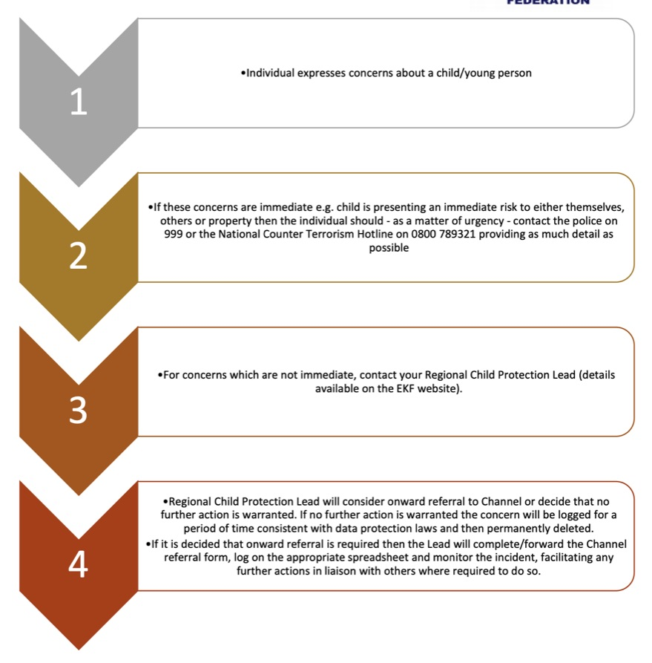

Appendix 2 – FGM Reporting Flowchart
You have concerns re: FGM
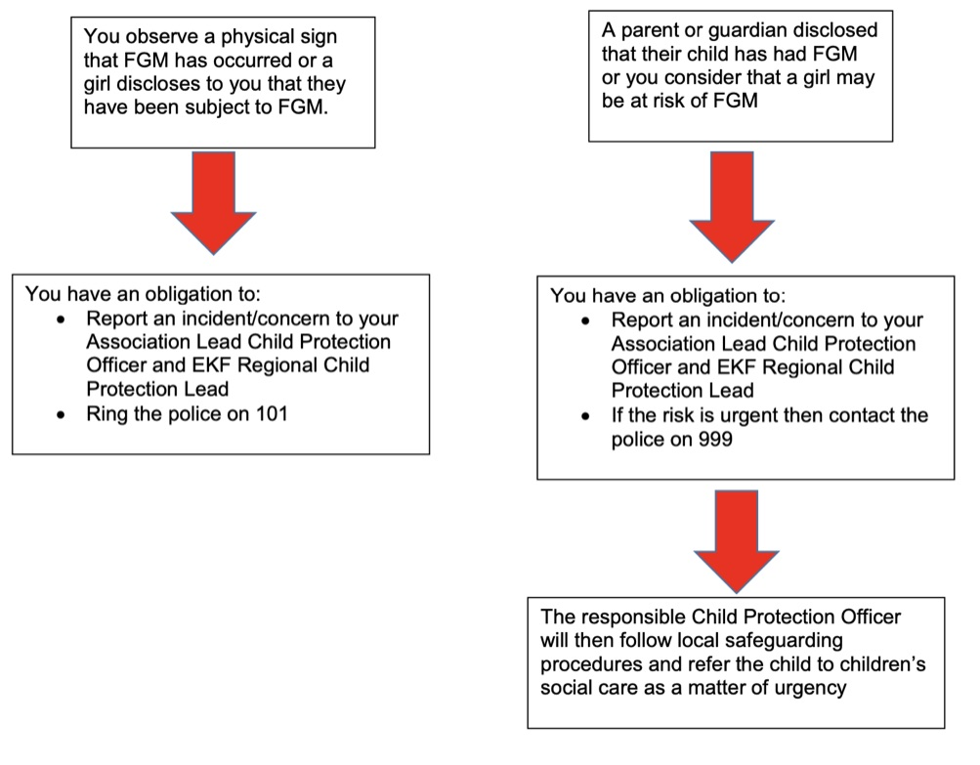

Appendix 3 – Child Safety and welfare concern flowchart

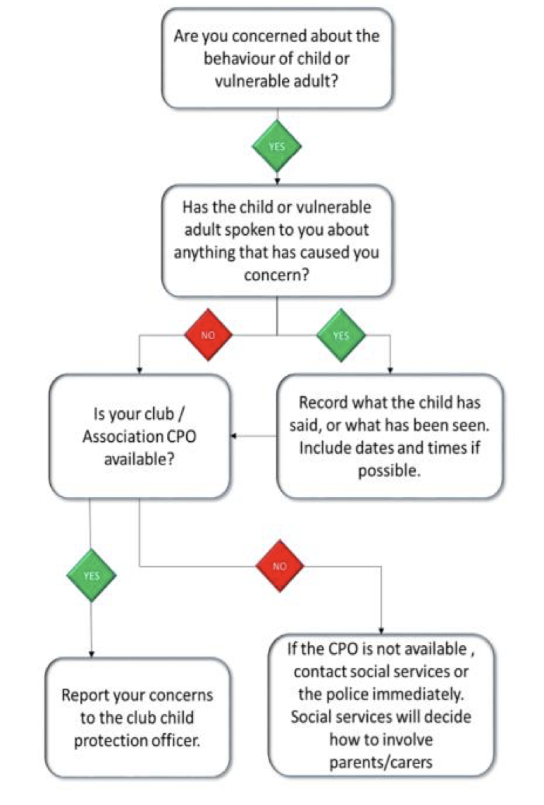

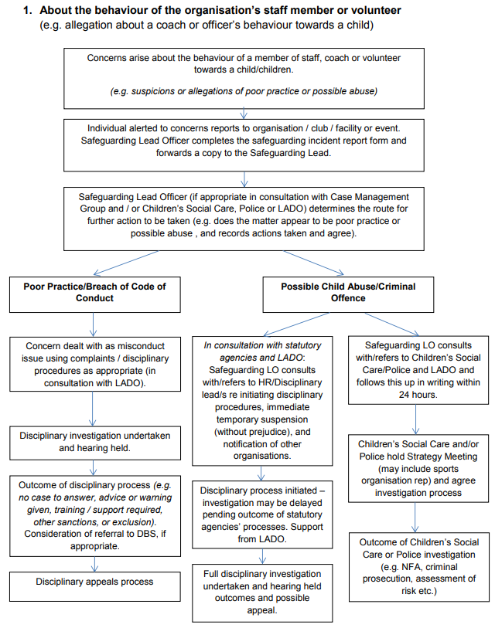

Appendix 4- Useful Contacts

Darran Findlater- Coach & Safeguarding lead- Darranfindlater@hotmail.com

David Wilson- Senior Instructor & Safeguarding officer- 07933326935- david_wilson31@sky.com

Katrina Wilson- Chief Instructor & Safeguarding lead- 07475765153- katrinajaywilson@gmail.com

NSPCC Child Protection Helpline on 0808 800 5000
Childline on 0800 1111

