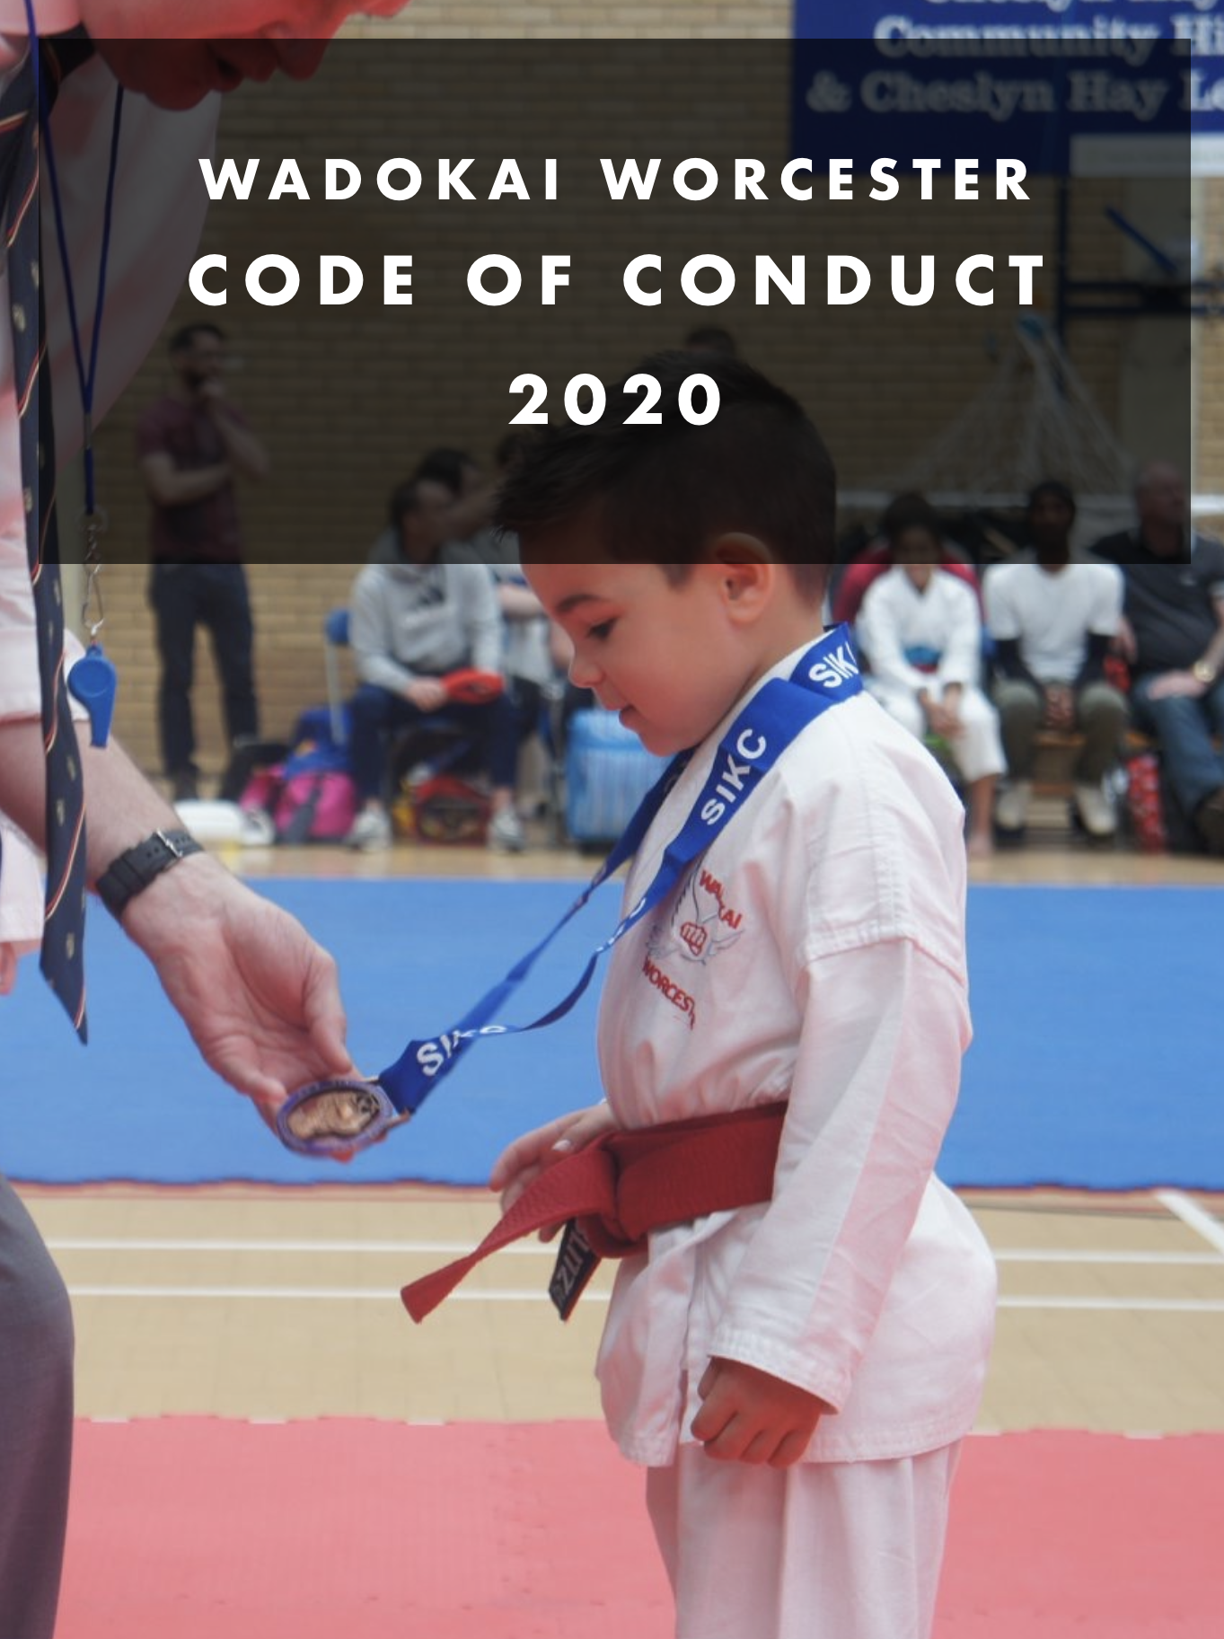

INTRODUCTION
The following information is for athletes and parents, detailing what is required of the students of WadoKai Worcester Karate in terms of rules to be observed and behaviour that is acceptable. This Code of Conduct is based upon self-discipline, good behaviour both in and out of the Dojo, smart appearance, punctuality, respect and consideration for others, their property, politeness, good manners, honesty and tolerance. These values apply equally to all karate events, whether they are domestic or International events. The forms attached to this document must be completed and returned as acceptance of this Code of Conduct.

ATTENDANCE AND PUNCTUALITY
Regular and punctual attendance at training events, pre-training events and selections is required and the co-operation of parents is expected to see that this is achieved for the Junior/Cadets members of the squad. Whilst occasional, isolated lateness maybe unavoidable, athletes cannot be consistently late in arriving for training or in missing compulsory training sessions.
Training with other martial arts clubs is permitted with permission from WadoKai Worcester, licensing with said club is acceptable again with permission from WadoKai Worcester. However, if permission is not granted it will result in Expulsion from WadoKai Worcester.
ANTISOCIAL/UNACCEPTABLE BEHAVIOURS
We do not wish to outline an exhaustive list of behaviours which is deemed to be antisocial or unacceptable however below are a list of examples which are to be used as guidelines;
- Offensive Language or Jesters
- Intimidation or peer pressure
- Publishing, circulating or displaying pornographic, racist, sexually suggestive or otherwise offensive material or pictures (Refer to Social media policy)
- Persistent or unreasonable criticism
- Drunkenness (See more below)
- Bullying
- Racism, Radicalisation, Sexism, Ageism Etc (See Equity & Equality Policy)
- Lying or Spreading malicious rumours or Gossip
- Vandalism
- Criminal Damage
- Stalking
- Assault
Any action that comes under the antisocial or unacceptable behaviours will be taken very seriously at WadoKai Worcester and upon circumstances may result in any of the following actions; Verbal Warning, Written Warning, Suspension or Expulsion.

RESPECT/PROFESSIONALISM
All Coaches, Team Leaders, Athletes/members should conduct themselves in a professional and sports person manner. This means we expect respect to all members at all times and to respect any decisions at any event, without showing disrespect. Some examples below;
- You respect all coaches and team managers that you train with at any event
- You respect Judges decisions at competitions
- You accept defeat gracefully and without outburst

DRINKING
There will be no consumption of alcohol whist representing WadoKai Worcester at any domestic or international event before and during the competition/training. Anyone under the age of 16 cannot consume alcohol at all whilst representing WadoKai Worcester as in line with UK Law. After the competition 16-17 Year old can drink beer, wine or cider with a meal if it is bought by the parent or guardian and they are accompanied by parent or guardian. It is illegal to buy people under 18 spirits even with a meal. It is against UK Law to buy alcohol for someone under 18 to drink in a pub or public place (this includes Hotel).
When over 18 we accept that legally you are allowed to drink however we expect you to do so in moderation and that you conduct yourself in a professional manner and do not bring the club into disrepute.

UNIFORM/APPEARANCE
Journeys to and from Karate events are occasions when WadoKai Worcester Karate Tracksuits are to be worn, therefore we expect athletes to conduct themselves accordingly and maintain the good name of the club, this includes wearing the attire correctly.
Competitors/Athletes/Members must wear a white karate gi without stripes, piping, or personal embroidery, other than specifically allowed by the WKF EC, The National emblem, flag of the country or club logo will be worn on the left breast of the jacket and may not exceed an overall size of 12cm by 8cm. Only the original manufactures labels may be displayed on the gi. In addition, identification issued by the organising committee will be worn on the back.
Competitors/Athletes/members must keep their hair clean, and cut to a length that doesn’t obstruct smooth bout conduct or training. Members must have short fingernails and toenails and must not wear metallic or other objects which may injure their opponent or training partner. Finally excessive makeup and false eyelashes are prohibited.

SOCIAL MEDIA
As stated above our policies apply within the dojo and outside of the dojo, at local, national and international events. For more on this subject please refer to our social media policy, below are some examples of unacceptable social media activity;
- Posting your beliefs as those of WadoKai Worcester
- Publishing, circulating or displaying Sexually explicit/suggestive, pornographic, racist, sexist, antisocial, offensive material or pictures
- Cyber bullying
- Use of offensive Language or jesters
- Intimidating, peer pressure, harassment, hostile or degrading actions
- Stalking
- Spreading malicious rumours or gossip

MOBILES
Mobile phones for athletes/ members are only to be used in an emergency, they’re not acceptable to be used for social aspect, recordings or pictures (please see Photography Policy) for research purposes only the WadoKai Worcester IPad may be used.

PROTECTION OF WADOKAI WORCESTER PROPERTY
Any wilful damages caused by a student or parent to any WadoKai Worcester equipment will be liable to pay for and replace as new. For example gouging the Mats is unacceptable and you may be charged for repair or replacement.
WadoKai Worcester Karate are not responsible for the loss of any possessions this includes clothing, licence nooks, grading syllabus or any other equipment. If replacements of WadoKai Worcester equipment are required the cost of said item/s will be applied. For example Licence replacement £10.

COLLABORATION
WadoKai Worcester karate pride ourselves on being a family friendly team unit, this means that we expect all students and parents to be friendly and supporting of other members and parents, we understand that you may not like every person you meet. However, you must remain civil in order to not disrupt the atmosphere at the club or training.

DISCIPLINE
The following disciplinary sanctions may be used at the discretion of the WadoKai Worcester Chief Instructor (Katrina Wilson) or the board of WadoKai Worcester;
- A verbal warning with parent/guardian present
- Exclusion from training events, accompanied by a letter to parent/guardian
- Final warning- may include suspension from WadoKai Worcester training or events, suspension from competitions or coaching for a period to be determined by the board. Parent/Guarding being expelled from the room.
- Expulsion from WadoKai Worcester Karate

Please be aware that depending on the nature of the offence that WadoKai Worcester may make the decision to result to the highest punishment of Expulsion if the board deems necessary.

It is worth mentioning that disciplinary action is designed for students or parents whose behaviour or appearance is not acceptable, or who have failed to put in the necessary time or effort to achieve their best results. They are not intended for the punishment of athletes who have genuinely tried their best and have not succeeded.

Parents are expected to:
- Positively reinforce their child/young person and show an interest in their chosen activity.
- Do not place their young person under pressure or push them into activities they do not want to do.
- Complete and return the Health and Consent Form pertaining to their child's participation with WadoKai Worcester Karate.
- Not supply alcohol to minors in line with UK law stated earlier in this policy
- Deliver and collect the child punctually to and from coaching sessions.
- Ensure their child is properly and adequately attired for the weather conditions of the time, including tracksuit, coat, hat, gloves etc. and has the correct clothing and protection for participation e.g. Gi, Obi, gum shields etc
- Ensure that proper footwear and protective equipment are worn at ALL times in accordance with Health and Safety Regulations. Any child not in possession of the fundamental requirements will not be permitted to participate.
- Detail any health concerns pertaining to the child on the consent form, in particular breathing or chest conditions. Any changes in the state of the child's health should be reported to the coach prior to coaching sessions.
- To inform the Coach prior to departure if child is to be collected early from a coaching session.
- Encourage their child to play by the rules and teach them that they can only do their best.
- Behave responsibly in the training area/Dojo; do not embarrass your child.
- Show appreciation and support the coach.
- Ensure their child is punctual.
- Be realistic and supportive.
- Provide their child with proper clothing and equipment.
- Ensure their child’s hygiene and nutritional needs are met.
- Accept the official’s judgement.

Parents/Guardians have the right to:
- Know their child is safe
- Be informed of problems or concerns relating to their children
- Be informed if their child is injured
- Have their consent sought for issues such as trips
- Complain if they have concerns about the standard of coaching.

Any misdemeanours and breach of this Code of Conduct will be dealt with immediately by a WadoKai Worcester Karate official. Persistent concerns or breaches will result in the parent/guardian being asked not to attend sessions if their attendance is detrimental to the child’s welfare. The ultimate action should a parent/guardian continue to breach the Code of Behaviour may mean WadoKai Worcester Karate officials regrettably asking the child to leave the session.

The Directors and Coaches of WadoKai Worcester Karate want parents and coaches to support their children and students, but we ask that you do so in the correct manner and with this in mind we have produced a Code of Conduct.
- Parents/Coaches must treat the training session with the same respect and etiquette as a Dojo session and observe the same protocols.

- When entering and leaving the training area/Dojo please observe the required protocols (no undue noise, mobiles etc.)

- If you are allowed to watch the proceedings, and then please be quiet, mobiles on silent or switched off etc.

- If you need to chat to another Coach or parent, then this requirement should be conducted outside of the training area/Dojo.

- By all means support your child/student, but in an appropriate manner

- Any misdemeanours and breach of this Code of Conduct will be dealt with immediately by WadoKai Worcester Karate official.

- Persistent concerns or breaches will result in the parent/guardian being asked not to attend sessions if their attendance is detrimental to the child’s welfare

- The ultimate action should a parent/guardian continue to breach the Code of Behaviour may mean WadoKai Worcester Karate officials regrettably asking the child to leave the Squad.

- At squad training and selection sessions vocal support is not allowed.

